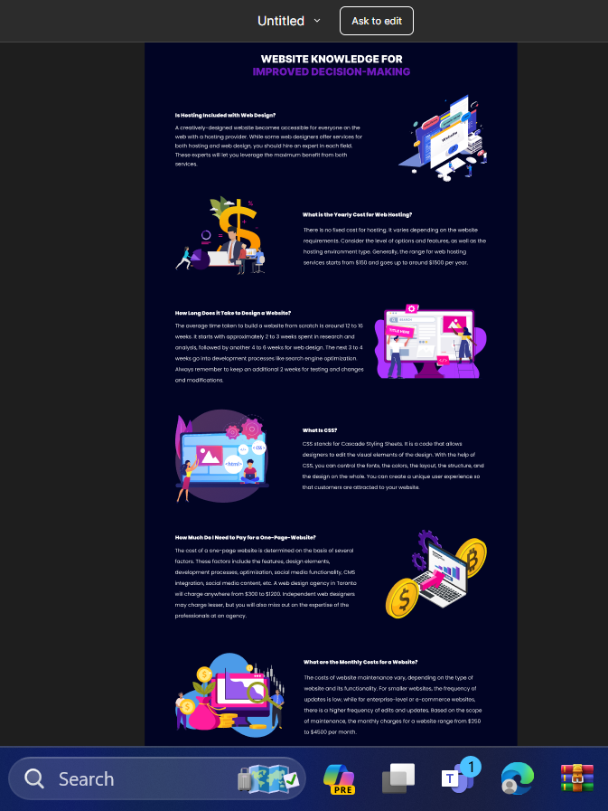

width: 1440px;

height: 17984px;

background: #010424;

Hadding-----------

display: flex;

width: 629px;

height: 97px;

flex-direction: column;

justify-content: center;

flex-shrink: 0;

color: #FFF;

text-align: center;

font-family: Inter;

font-size: 40px;

font-style: normal;

font-weight: 900;

line-height: 49px; /\* 122.5% \*/

text-transform: uppercase;

color: #701ABC;

font-family: Inter;

font-size: 40px;

font-style: normal;

font-weight: 900;

line-height: 49px;

text-transform: uppercase;

text------------WEBSITE KNOWLEDGE FOR IMPROVED DECISION-MAKING

sub Heading ------------------------

display: flex;

width: 417px;

height: 24px;

flex-direction: column;

justify-content: center;

flex-shrink: 0;

color: #FFF;

font-family: Poppins;

font-size: 20px;

font-style: normal;

font-weight: 900;

line-height: 24px; /\* 120% \*/

text---------------------

sub-h 1==Is Hosting Included with Web Design?

sub-h 2== What is the Yearly Cost for Web Hosting?

sub-h 3== How Long Does it Take to Design a Website?

sub-h 4== What Is CSS?

sub-h 5== How Much Do I Need to Pay for a One-Page-Website?

Sub-h 6== What are the Monthly Costs for a Website?

Para1---- A creatively-designed website becomes accessible for everyone on the

web with a hosting provider. While some web designers offer services for

both hosting and web design, you should hire an expert in each field.

These experts will let you leverage the maximum benefit from both

services.

Para 2-- There is no fixed cost for hosting. It varies depending on the website requirements. Consider the level of options and features, as well as the hosting environment type. Generally, the range for web hosting services starts from $150 and goes up to around $1500 per year.

Para3----

The average time taken to build a website from scratch is around 12 to 16 weeks. It starts with approximately 2 to 3 weeks spent in research and analysis, followed by another 4 to 6 weeks for web design. The next 3 to 4 weeks go into development processes like search engine optimization. Always remember to keep an additional 2 weeks for testing and changes and modifications.

Para4---

CSS stands for Cascade Styling Sheets. It is a code that allows designers to edit the visual elements of the design. With the help of CSS, you can control the fonts, the colors, the layout, the structure, and the design on the whole. You can create a unique user experience so that customers are attracted to your website.

Para5—

The cost of a one-page website is determined on the basis of several factors. These factors include the features, design elements, development processes, optimization, social media functionality, CMS integration, social media content, etc. A web design agency in Toronto will charge anywhere from $300 to $1200. Independent web designers may charge lesser, but you will also miss out on the expertise of the professionals at an agency.

Para6—

The costs of website maintenance vary, depending on the type of website and its functionality. For smaller websites, the frequency of updates is low, while for enterprise-level or e-commerce websites, there is a higher frequency of edits and updates. Based on the scope of maintenance, the monthly charges for a website range from $250 to $4500 per month.











